Tasks:
- Added Task. Hit Edit and rather than open it in edit mode it opened it in add mode.
- Didn’t want to add so hit cancel and got the following error:
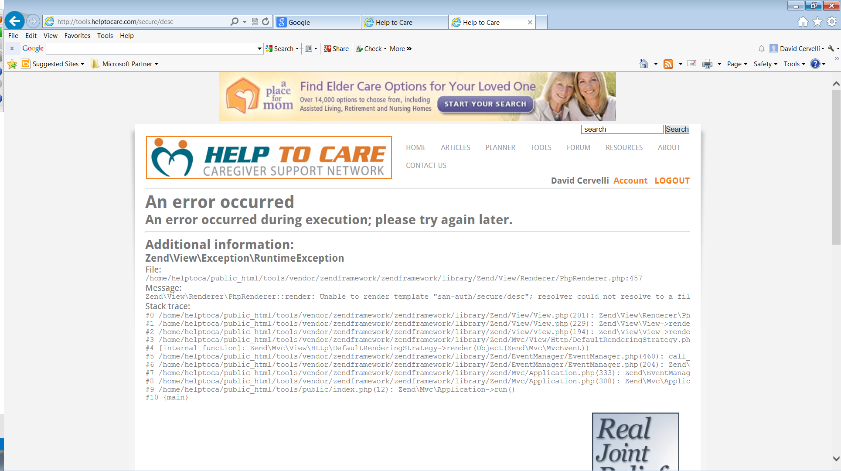

Documents. Added a PDF and TXT file but can’t add a Word or Excel document.

