Tasks:

1. Added Task. Hit Edit and rather than open it in edit mode it opened it in add mode.
2. Didn’t want to add so hit cancel and got the following error:

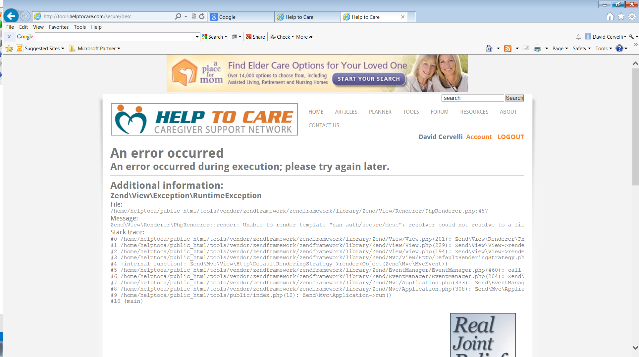

Documents. Added a PDF and TXT file but can’t add a Word or Excel document.