06/15/2013

1. Login Dialog / Authentication Failure

Invalid credentials or your account has not been activated.

Suggested wording:

The e-mail address or password you provided is incorrect or your account has not yet been activated.

------

2. Registration Form

##### **Registration Successful**

Thank you for your interest in Help To Care! Your registration is complete, however, before you can log in you must first activate your account by clicking on the link provided in the e-mail confirmation that was just sent to you. Once your account is activated, you will be presented with a login form.

Please [click here](http://tools.helptocare.com/) to return to the Help To Care home page.

Suggested wording for the last sentence in the paragraph above:

Once your account is activated, you will be directed to the Help To Care Sign In page.

-----

3. Add Profile Dialog

# **Cared-For Information**

Please fill out the information for this Cared-for profile.

Only First Name and Last Name are required you can fill out others information at a later time.

-----

Suggested wording:

Please provide the following information for the person being cared for.

Only First Name and Last Name are required. You can provide additional information at any time.

-----

4. Inviting a Caregiver

The Person with the email address that you entered does not currently have a Help To Care login.

An email has been sent to them requesting that they register. Once this person registers, they will have access shared with them.

Please [click here](http://tools.helptocare.com/secure/) to go back to profiles listing.

Who has access:

|  |  |  |  |
| --- | --- | --- | --- |
| **Email Address** | **Last Modified** | **Permissions** | **Del** |
| brian.iinuma@ssgnet.com |  | (owner) |  |
| leted25@yahoo.com | 2013-06-15 12:26:18 | can_edit |  |
| dcervelli@ssgnet.com | 2013-06-15 12:30:22 | can_edit |  |
| bogus@domain.com | 2013-06-15 12:32:35 | can_view |  |

Suggested wording:

The person with the e-mail address that you entered does not currently have a Help To Care login. An e-mail message has been sent requesting that he or she create a profile in the Help To Care Caregiver Support Network. Once done, this person will have access to the information you just shared with them. Should it be necessary, this access can be revoked at any time.

Please [click here](http://tools.helptocare.com/secure/) to return to Profiles listing.

If the invited person has not registerd (accepted invitation), then show "Pending" to the right of the permission. Example: Edit -Pending

For consistency, please change the permissions display: “can_edit” should be “Edit” and “can_view” should be “Display”.

Change "Last Modified" format from: 2013-06-14 17:29:34 to 06/14/2013 17:29:34

-----

5. Add Medications

No medications have been entered. Please click the Add Medications button to enter medications.

Suggested wording:

No medications have been entered. Please click the Add Medications button to enter the first medication for this profile.

-----

6. Add Contacts

No contacts have been entered. Please click the Add Contacts button to enter contacts.

Suggested wording:

No contacts have been entered. Please click the Add Contacts button to enter the first contact for this profile.

-----

7. Add Tasks

No tasks have been entered. Please click the Add Tasks button to enter tasks.

Suggested wording:

No tasks have been entered. Please click the Add Tasks button to enter the first task for this profile.

-----

8. Contacts E-mail Address

The entered Email address is invalid.

Suggested wording:

The format of the e-mail address entered is incorrect.

9. Documents - Document Name / View

|  |  |  |  |
| --- | --- | --- | --- |
| Scenery | Blue Hills | [View](http://tools.helptocare.com/upload/8_1371314990.jpg) | Delete |
| Scenery | Sunset | [View](http://tools.helptocare.com/upload/8_1371315018.jpg) | Delete |
| Scenery | Winter | [View](http://tools.helptocare.com/upload/8_1371315168.jpg) | Delete |
| Scenery | Water Lilies | [View](http://tools.helptocare.com/upload/8_1371315195.jpg) | Delete |

The name of the document can be the same for multiple documents. Was this behavior intended?

KG answer: Yes, it is possible. No action needed.

After viewing the document, how should the user return to the document listing. The “Back” button works, but may not be the best solution.

KG: Open the document (if it is something that can be viewed) In an new pop-up window. If not viewable, then it will be downloaded.

-----

10. Documents - Listing Display

Home ›› Albina Cervelli ›› Documents

|  |  |  |  |
| --- | --- | --- | --- |
| **Document** | **Description** | **View** |  |
| test pic | Test Pic | [View](http://tools.helptocare.com/upload/7_1371314625.JPG) | Delete |
| test excel | test excel | [View](http://tools.helptocare.com/upload/7_1371314802.xlsm) | Delete |
| test word document | test word | [View](http://tools.helptocare.com/upload/7_1371314842.docx) | Delete |
| logo | Logo | [View](http://tools.helptocare.com/upload/7_1371315412.png) | Delete |
| VVVVVVVVVVVVVV EEEEEEEEEEEEEEE RRRRRRRRRRRRRRR YYYYYYYYYYYYY LLLLLLLLLLL OOOOOOOOOOOOOO NNNNNNNNNNNNNNNNN GGGGGGGGGGGGGGGGGGGG | VVVVVVVVVVVVVVVVVVVVVVVVVVVVVVVVVVVVV EEEEEEEEEEEEEEEEEEEEEEEEEEEEEEEEEE RRRRRRRRRRRRRRRRRRRRRRRRRRR | [View](http://tools.helptocare.com/upload/7_1371315596.png) | Delete |

Should “Document” be “Document Name”? KG: Yes

Should the actual file name be displayed? KG: Yes.

Should the user be able to modify the “Document Name” and “Description”? KG: Pending

Should a free-form “Notes” field be added? KG: This will be added in a future phase as "comment"

Should a “Category” field be added? Should a sort / filter by category be added? KG: Document upload capability will be added by section, so will be somewhat auto-categorized. We may add categories in the future, but not needed yet.

-----

11. Lita’s Documents Display

Home ›› Lita Eduarte ›› Documents

|  |  |  |  |
| --- | --- | --- | --- |
| **Document** | **Description** | **View** |  |
| Scenery | Blue Hills | [View](http://tools.helptocare.com/upload/8_1371314990.jpg) | Delete |
| Scenery | Sunset | [View](http://tools.helptocare.com/upload/8_1371315018.jpg) | Delete |
| Scenery | Winter | [View](http://tools.helptocare.com/upload/8_1371315168.jpg) | Delete |
| Scenery | Water Lilies | [View](http://tools.helptocare.com/upload/8_1371315195.jpg) | Delete |
| Dance | Zumba | [View](http://tools.helptocare.com/upload/8_1371317083.txt) |  |

Note: there is no “Delete” option for “Dance”. After viewing “Dance” document. Unfortunately, this may be transient or intermittent. KG: Pending

Home ›› Lita Eduarte ›› Documents

|  |  |  |  |
| --- | --- | --- | --- |
| **Document** | **Description** | **View** |  |
| Scenery | Blue Hills | [View](http://tools.helptocare.com/upload/8_1371314990.jpg) | Delete |
| Scenery | Sunset | [View](http://tools.helptocare.com/upload/8_1371315018.jpg) | Delete |
| Scenery | Winter | [View](http://tools.helptocare.com/upload/8_1371315168.jpg) | Delete |
| Scenery | Water Lilies | [View](http://tools.helptocare.com/upload/8_1371315195.jpg) | Delete |
| Dance | Zumba | [View](http://tools.helptocare.com/upload/8_1371317083.txt) | Delete |

After changing screens or refreshing, the “Delete” option is present.

**12. Failed Document Upload Issue (David)**

I created a word document on my desktop and saved it as test.doc.

I tried to add it as Document Name ‘test word doc’ and Description ‘test word doc’ failed. I assume it failed because I never exited Word and test.doc was locked.

I closed Word and attempted to save the same document as the same name and description and it failed (see below).

I was able to add a document as ‘test word document’ using the file test.doc but I couldn’t add this document as ‘test word doc’.

When I cleared my cache I was able to save the document. KG: Pending

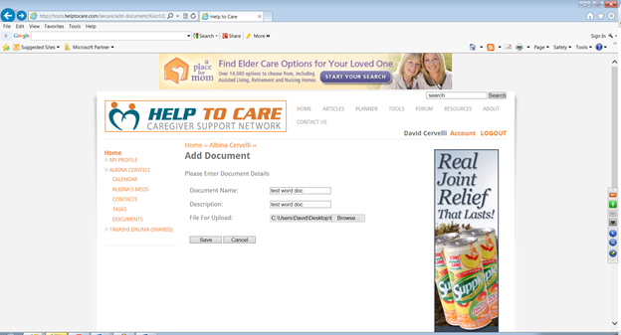

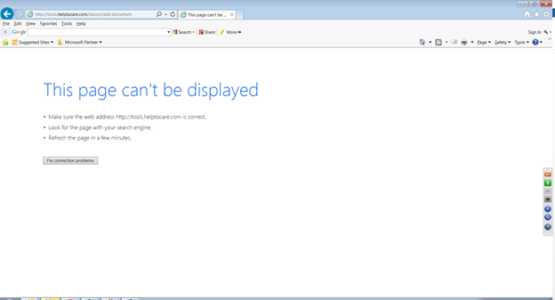

13. Lost Password Dialog

# **Lost Your Password Page**

Please enter the email address that you used when

registering for The Help To Care Network:

Suggested wording:

**Lost Password Assistance**

Please enter the e-mail address that you used to register for The Help To Care Caregiver Support Network:

-----

14. Lost Password Confirmation

# **Lost Your Password Page**

**Your password has been reset.**

**An email has been sent to your email address and should be arriving within 5 minutes.**

**Please check your email for details.**

**- The Help To Care Network**

Please enter the email address that you used when

registering for The Help To Care Network:

Suggested wording:

**Lost Password Assistance**

Your password has been reset.

A message has been sent to your e-mail address that should arrive within 5 minutes. It will contain a temporary password with which you will be able to log in. Please change your password when prompted.

(end of suggested wording)

Also, please delete the text related to “Please enter the email address that you used ...” and provide link to the login form. KG: Link to the default home page that will redirect the user to the right place.

-----

15. Lost Password E-mail Message:

From: Help to Care Support <support@htc.com>

Subject: Your password has been reset successfully.

Dear <FirstName> <Lastname>,

As you requested, your password has now been reset.

Your new login details are as follows:

Email: brian.iinuma@ssgnet.com

Password: NYqb24

To change your password to something more memorable, after logging, click on the "Account" link.

Sincerely,

The Help To Care Network

Suggested wording:

From: Help To Care Support <support@helptocare.com>

Subject: Password Reset

As you requested, your password has been reset. Please use the following information to log in:

E-mail Address: (the e-mail address you used to register)

Password: NYqb24

After logging in, please change your password when prompted.

Sincerely,

The Help To Care Caregiver Support Network